**MESA PRACTICAL HOMEWORK 3**

**In this Homework Practical I have successfully implemented Blink program for Nucleo-F401RE development Kit.**

1. **Where (at what address) does the Reset handler begin?**

**Answer:** Reset handler is at 0x8000458 as shown by the disassembly window.

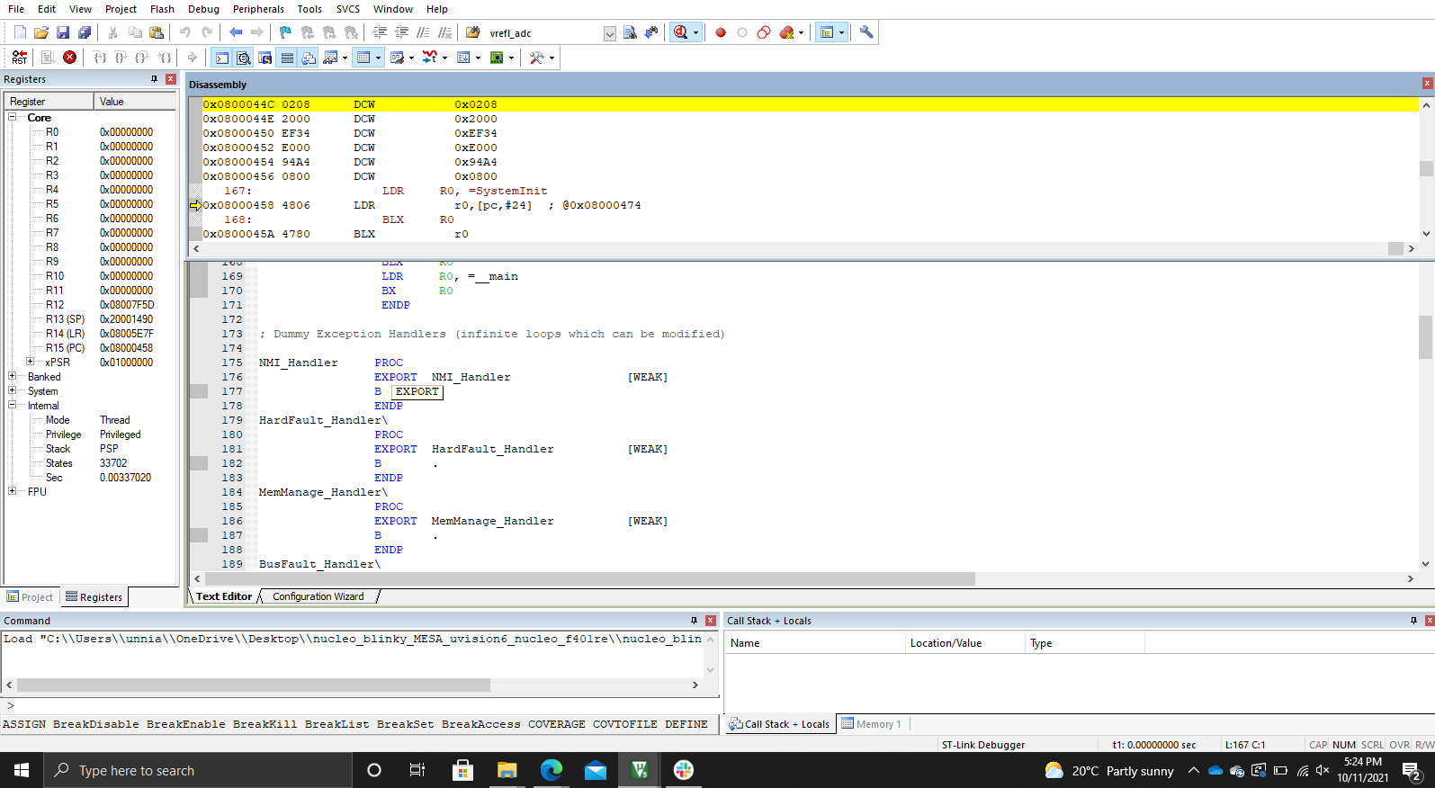

1. **How much memory is used by the code?**

**Answer:** Memory used by the code is 36.340 KB as shown by the compiler after compiling the OS blinky code for Nucleo-F401RE

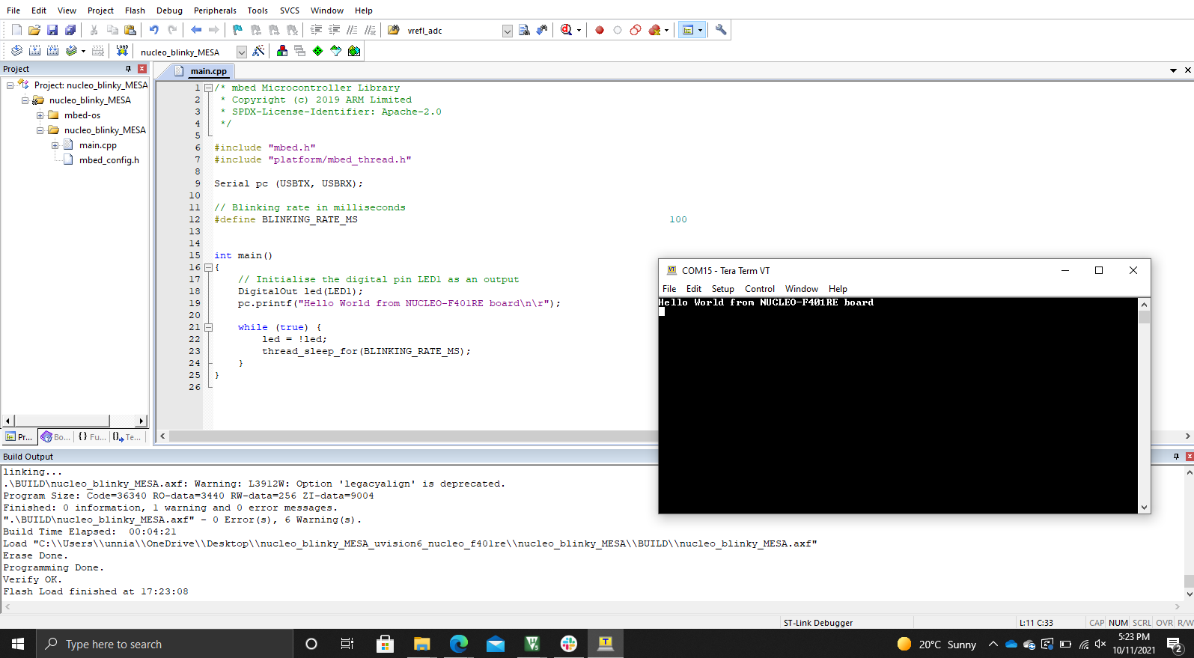

1. **Run the mBed Nucleo Example display time. Set the time to the current time, and combine this with you’re the mBed Nucleo Example printf to print the current time to a terminal window on your PC. Capture a screen shot of the terminal window.**

**Solution:**

**Code:**

/*

* Copyright (c) 2006-2020 Arm Limited and affiliates.

* SPDX-License-Identifier: Apache-2.0

*/

#include "mbed.h"

int main()

{

set_time(1633746058 - 21600); // Set RTC time to Oct 8th, 2021, 8:22 PM

while (true) {

time_t seconds = time(NULL);

printf("Time as seconds since January 1, 1970 = %u\n\r", (unsigned int)seconds);

printf("Time as a basic string = %s\n\r", ctime(&seconds));

char buffer[32];

strftime(buffer, 32, "%I:%M %p\n\r", localtime(&seconds));

printf("Time as a custom formatted string = %s\n\r", buffer);

ThisThread::sleep_for(1000);

}

}

**Output:**

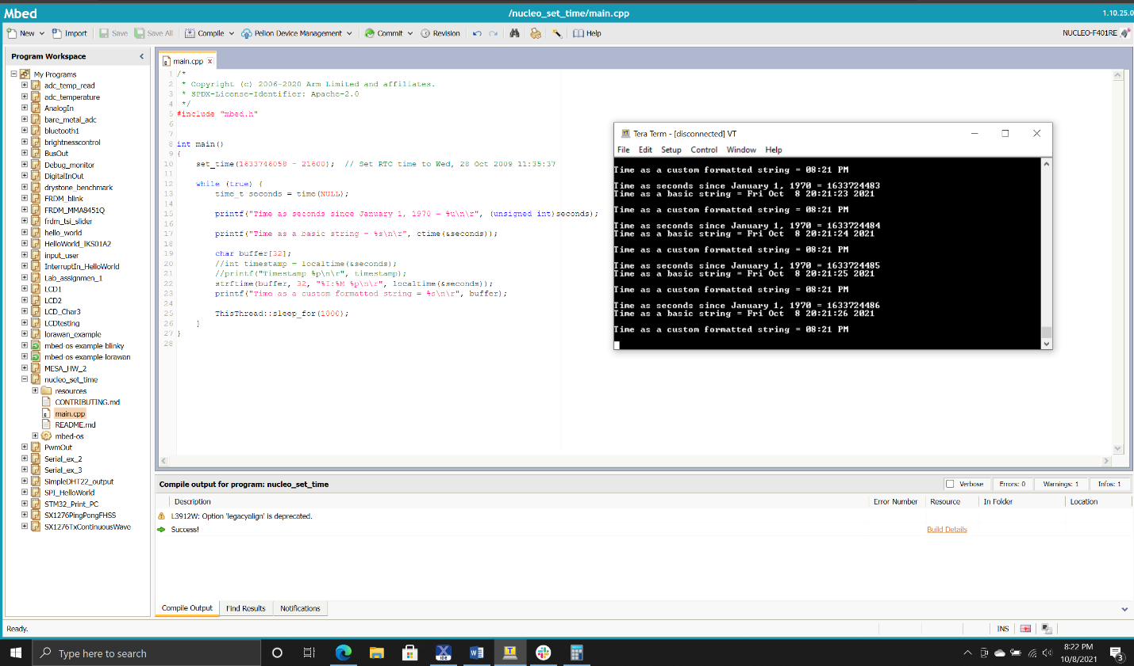

1. **Explain the memory model of ARM Cortex-M4 with respect to the code memory, data memory, IRQ handlers and peripherals. Explain with the help of a diagram where required.**

**Answer:**

1. **As a separate project, run either the Dhrystone or the Whetstone benchmark program on your target processor using the code provided, which may need to be modified. If running the Dhrystone, calculate the number of VAX DMIPS.**

**Answer:** DMIPS after running Dhrystone benchmark for Nucleo-F401RE comes out to be 129.9 VAX

